Math Interactive Notebook Guidelines
Ridge Road Middle School - 7th Grade

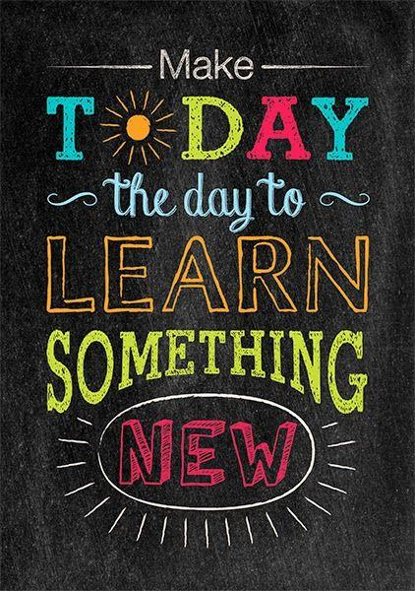
The purpose of the interactive notebook is to:
- Organize notes, classwork, and homework
- Involve students in “making sense” of their notes
- Develop visual aids for learning
- Create a personalized math study guide
- Teach students different approaches to learning
that will prepare them for future success in school.

Materials Needed:
- Spiral notebook
- Glue
- Scissors
- Pencils/pens
- Highlighters
- Crayons/colored pencils/markers

How to get an A on my interactive Notebook:
- Keep your table of contents completely updated
- Have ALL pages in the notebook in the correct order
- Have ALL pages in the notebook 100% complete.
- Keep your notebook organized and neat (i.e. legible handwriting, clear notes and work, no papers coming out of edges, etc.)

Friendly Reminders:
- Make sure assignments are completed - You will not get full credit for incomplete work.
- Make sure assignments are on the correct page – I will not search for your assignment.
- Update your Table of Contents each day!
- Your notebook needs to be in class every day.
- If you are absent, it is your responsibility to complete missed pages.

“The person who does the work is the only one who learns.” - Harry Wong

