Unit 4 Volume and Surface Area STUDY GUIDE
Find the Volume.
Formulas:  Prisms: V = Bh  Pyramid: V = Bh  3  Steps:  - Highlight/ Redraw the Base.  - Find the area of the base (B)  - Find the height (h)  - Substitute into formula.  - Solve. | 1.  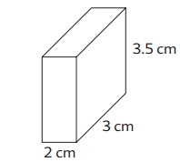 | 2.  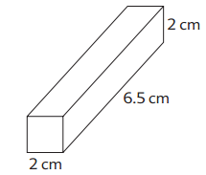 | 3.  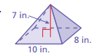
 | 4.  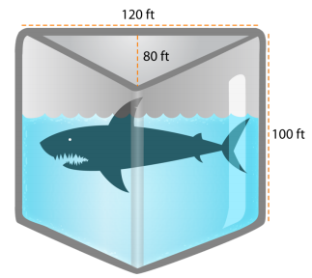 | 5.  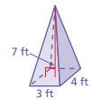 | 6.  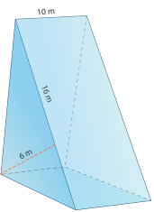

7.  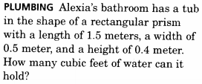 | 8.  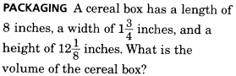
9.  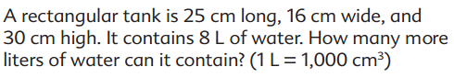 | 10. Jake found an old toy pyramid while he was cleaning out his closet. To help him finish cleaning out his closet, he placed all his old toys in the pyramid. If the pyramid had a height of 12 inches, a slant length of 15 inches, and a side base of 10 inches, how much could the pyramid hold?
11.  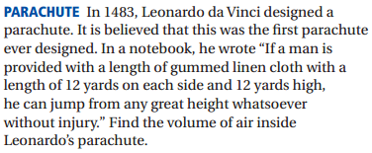 | 12.  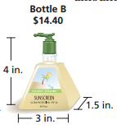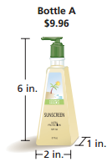

Surface Area
SA= 2B + PH  Steps:  - HIghlight/ Redraw the base.  - Find the area of the base (B).  - Find the Perimeter of the base (P)  - Find the height (h)  - Substitute and Solve. | 13. 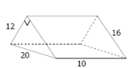 | 14.  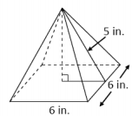 | 15.  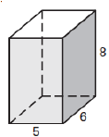 | 16.  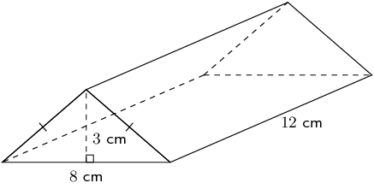

17. Donnovan wanted to wrap the gift below. How much paper is he going to need?  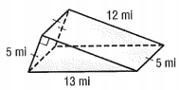 | 18. You have a square pyramid. The area of the square is 25 and the slant height of the pyramid is 10. Find the total surface area of the pyramid.
19. Suppose the length of each of a cube of ice is 4 centimeters. Find the surface area of the cube. | 20. What is the surface area of a square-based pyramid with base side lengths of 16 meters, a slant height of 17 meters, and a height of 15 meters?
21. The top and sides of the cake shown below are to be covered in frosting. How much frosting are they going to need to cover the cake?  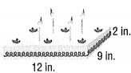 | 22. How much paint are you going to need to paint the entire figure to the right? (you do paint the bottom of the rectangles)  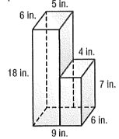

Working Backward
23. Find the value of x when SA = 200 ft2  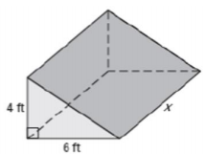  7.2 | 24. If the Surface area of this shape is 54in2 , what is the value of x?  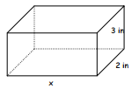
25.. Find the width of a rectangular solid with length 15 cm, height 8 cm, and Volume of 480 cm3 | 26. The Volume of square pyramid is 784 . If the base edge is 14 centimeters, then how tall is the pyramid?
Answer Key:
- 21
- 26
- 186.7
- 480000
- 480
- 28
- 4
- 169.75
- .3
- 1200
- 576
- 3:2, B
- 672
- 96
- 236
- 312
- 210
- 125
- 96
- 800
- 300
- 578
- 24.4
- 4.2
- 4
- 12

