UNIT 3: Rates, Ratios and Proportions STUDY GUIDE
Unit Rate
- Four gallons of gasoline cost $16.80. What is the price per gallon? | 2) Which is the best buy?  6 shirts for $25.50 4 shirts for $18.00 5 shirts for $21
Unit Rate with Complex Fractions
3) Emma drank 1/4 of a milkshake in 1/10 of an hour. How many minutes will it take her to drink a full milk shake? | 6) Lillian eats 1/4 of a pound of grapes in 1/17 of a minute. How many minutes will it take her to eat a full pound of grapes?
4) A bucket of water was ⅙ full, but it still has 2 ¾ gallons of water in it. How much water would be in one fully filled bucket? | 7) Lauren bikes 1 ⅓ miles in 1/10 hour. What is her rate of speed in miles per hour?
5) A recipe calls for using ¾ cup of brown sugar for each ⅔ cup of white sugar. How many cups of brown sugar are used per cup of white sugar? | 8) Joey plans to jog 6 miles to the store. He can jog at a constant rate of ½ of a mile every ¼ of an hour. How many hours will it take him get to the store?
Proportional Relationships from a Graph
9) List the 3 things a graph must have to show a Proportional Relationship.

1)_______________________________ 2)______________________________ 3)______________________________
Does the graph represent a Proportional Relationship? (Circle Proportional or Nonproportional)
10)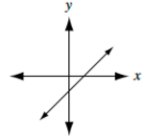 Proportional Non-proportional | 11)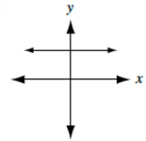Proportional Non-proportional | 12)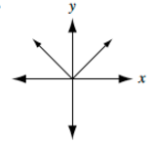Proportional Non-proportional | 13)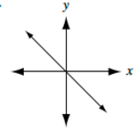Proportional Non-proportional | 14)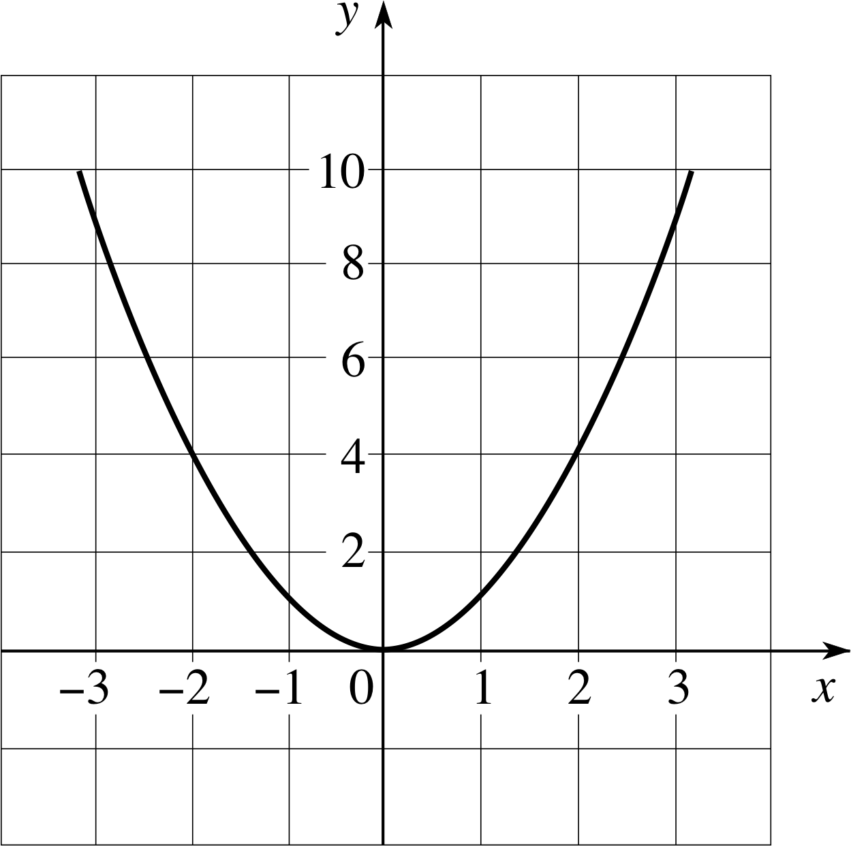Proportional Non-proportional

15) The graph below represents the number of balls thrown over time. What is the constant of proportionality?  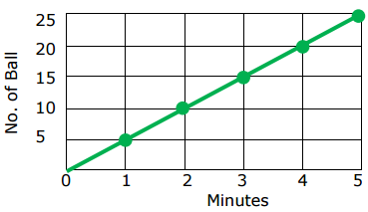 | 16) The graph below represents the number of vertical jumps Ava can do over time. How many jumps can she do per minute?  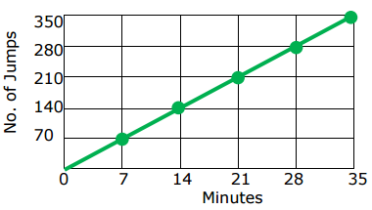

Proportional Relationship from a Table
Do the values represent a Proportional Relationship? (Circle Proportional or NonProportional)
17) $\frac{7}{14}, \frac{4}{8}$  Proportional Non-Proportional | 18) (0,0) , (3,4) , (6,8) , (9,12)  Proportional Non-Proportional | 19) $\frac{3}{8} , \frac{6}{14}$  Proportional Non-Proportional
20) $\frac{3}{28} , \frac{6}{56}$  Proportional Non-Proportional | 21) (0,0) , (1,2) , (2,4) , (4,16)  Proportional Non-Proportional | 22) (1,1) , (2,2) , (3,3) , (4,4)  Proportional Non-Proportional

23) Find the ratio of y to x for Table 1 and Table 2, simplify the fraction to simplest form.

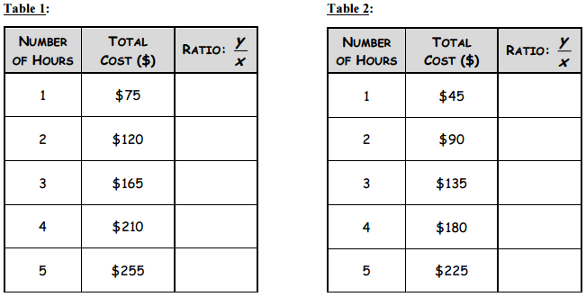

- Which table shows a proportional relationship?

________________________

b) What makes it a proportional relationship?

______________________________________
24) Isabella made necklaces with beads. If the quantities are proportional, what is the constant of proportionality?  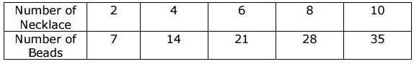 | 25) 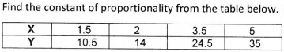
26) Write an equation that represents the relationship.  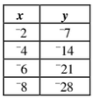 | 27) Write an equation to represent the data in the table.  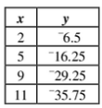
28) At a candy store, all the candy is sold by weight. The table below shows the cost to purchase candy by weight.  Weight of Candy (pounds) Cost ($)  2 5.12  4 10.24  6 15.36  Write an equation to calculate the cost of pounds of candy, x. | 29) The table shows how the number of people who ride a roller coaster depends on the number of cars on the rollercoaster.  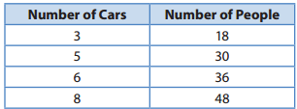  - How many people can ride in 1 car?______  - In 10 cars?______

Answer Key
1) $4.20
2) 5 shirts for $21 ($4.20)
3) 24
4) 16 ½
5) 4/17
6) 13 ⅓

1) straight line (linear) 2) constant of proportionality 3) goes through origin
10) Nonproportional
11) nonproportional
12) nonproportional
13) proportional
14) nonproportional
15) 5
16) 10
17) proportional
18) proportional
19) nonproportional
20) proportional
21) nonproportional
22) proportional
23) a) table 2 b) constant rate of change
24) 3.5
25) 7
26) y = 3.5x
27) y = -3.25x
28) y = 2.56x
29) a) 6 b) 60

