Name: _______________________________ Block: _____ 7th Gr Math
Homework WEEK 14
Solve the following problems without a calculator. You MUST show your work.
NO WORK = NO CREDIT.
Homework – Monday
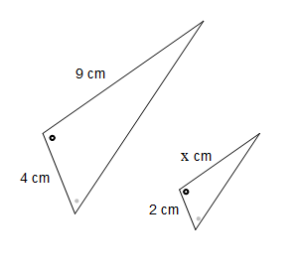  1. A music store is having a clearance sale. All items are discounted by 10%. What is the sale price of a radio that regularly costs $38? | 2. The cost of a taxi ride is $3.00, plus $0.60 for each mile traveled. Ms. Johnson was charged $15.60 for a taxi ride. How many miles was Ms. Johnson’s taxi ride?
3. Lauren deposited $200 into an account. The account pays simple interest at a rate of 6%. How much money will be in Lauren’s account at the end of 7 years? | 4. The math club at a middle school increased from 62 to 78 in one school year. What is the approximate percent of increase? (Round to the nearest tenth.)

Homework- Tuesday
1. Truth has $3 more than twice as much money as Schyler. If Truth has $10, how much does Schyler have? | 2. Samuel is 5ft 3in. He is standing next to a tree that is 26ft. If Samuel’s shadow is 8.5ft, what is the length of the tree’s shadow. (round to the nearest foot)
3. Jamison ordered 4 CDs for $48.96, which includes a $5.00 shipping charge. If each CD was the same price, what was the cost of each CD? | 4. If a small airplane travels 28 miles in 12 minutes, how far will the plane travel in one hour?

Homework - Wednesday
- Find the value of x if both triagles are similar.  8.2  16.4  x  10.5 | 2. If the price of a CD that normally costs $17.50 was marked up by 8%, what is the new cost?
3. Simplify.  8 - 4 (2 + 5²) ÷ 12 | 4. On a map 3in represeents 5.5 miles. How many miles away is city A from city B if on the map they are 12 in apart?

Homework - Thursday
1. Tracy’s weekly pay increased from $80 to $100. What is the percent increase in Tracy’s weekly pay? | 2. Hilda earns $15 in gratuity for every $100 in food served. If Hilda serves $500 in food, what is her gratuity?
3. Ms. Jenkins works at the Coach Store selling handbags. She gets a 5% commission on her weekly sales. She sold $6500 last week. How much commission did Ms. Jenkins earn? | 4. Simplify.  (6 x 9) + 3 x 12 - 4 ÷ 2

