Name: ____________________________
WEEK 16 HW
Solve the following problems without a calculator. You MUST show your work. NO WORK = NO CREDIT.
Homework – Monday
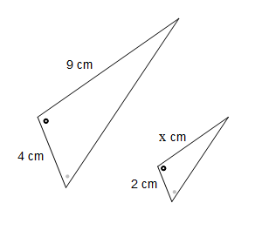  1. What is the compliment of an angle that measures 28º? | 2. What is the supplement of an agle that measures 117º?
3. A map is shown below.  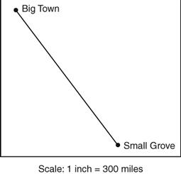  What is the actual distance between Big Town and Small Grove, if they are 2.5in apart on the map? | 4. A photograph was reduced using the scale factor of ⅔. The original photograph was 9 inches wide and 12 inches long. Which proportion could be used to find w, the width of the reduced photograph?  A) 9 = 2 C) 12 = 2  w 3 w 3  B) w = 2 D) w = 2  9 3 12 3
Homework – Tuesday
1. Explain the difference between complementary and supplementary angles. | 2. Explain the difference between adjacent and vertical angles.
3. Find the value of x.  4x - 3  19 | 4. A scale drawing of a room used a scale of 2.75 inches = 5 feet. An object is 4 inches long in the drawing. What is the approximate length of the actual object? (Round to the nearest hundredth.)

Homework - Wednesday
1. Given the value of the missing angle measures:  Angle Compliment Supplement Vertical  35º  86º | 2. Find the value of x.  114  2x + 5
3. The two triangles are similar what is the missing side?  16  x  10  24 | 4. Use the formula a² + b² = c² to find the missing side length. (Round to the nearest tenth.)  5  7  c

Homework - Thursday
1. Find the value of x.  2x  x  15 | 2. Which angles are congruent?  a  b  c  d
3. Write an equation that would be used to find the supplement of a given angle. | 4. Write an equation that would be used to find the complement of a given angle.

