Name: ____________________________
WEEK 17 HW
Solve the following problems without a calculator. You MUST show your work. NO WORK = NO CREDIT.
Homework – Monday
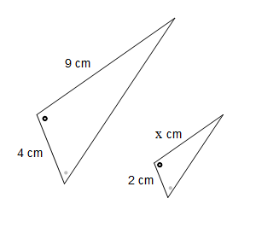  1. Simplify.  -4 (3x - 3) + 9 (x + 1) | 2. Write two formulas that can be used to find the circumference of a circle. Label each part.
3. Describe a similarity and a difference between radius and diameter. | 4. Mindy is mailing a package that weighs 9 pounds. She adds a book to the package that weighs 3 pounds. What is the percent of increase in the weight of the package? (Round to the nearest whole percent.)

Homework- Tuesday
1. Two supplementary angles are labeled: 4x - 3 and 2x. What is the measure of the larger angle? | 2. Two complementary angles are labeled: 5y and  y - 5 . What is the measure of the smaller angle?
3. What does it mean to find the area or circumference of a circle “in terms of pi”? | 4. A circle has a diameter of 30 centimeters. What is the circumference? Use 3.14 for pi.

Homework - Wednesday
3. Kalyn put $2,500 in a savings account at a simple interest of 3.9%. If Kalyn does not add or remove any money from the savings account, how much money will she earn after 6 years? | 4. How would the circumference and area of a circle change if the radius is doubled?
5. What is the area of a circle with a radius of 15.4mm? | 6. There is a circular garden along the side of a garage. What does the length of the fencing around the garden represent?

Homework - Thursday
1. Write the steps needed to find the radius of a circle when given the area. | 2. Write the steps to find the diameter of a circle when given the circumference.
3. The radius of a circle is 12cm. What is the circumference of the circle in centimeters? Express your answer in terms of pi. | 4. Find the area of a circle whose diameter is 10 cm. Use 3.14 for pi.

