Name: ____________________________
Week 18 Homework
No Calculators!!!!!
NO WORK=NO CREDIT!!!!
Monday
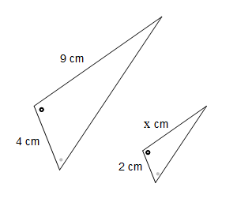  1. Find the area of a circle whose radius measures 25 meters, to the nearest tenth. | 2. What is the formula for volume of a rectangular prism? Label each part. How is it different from a cube? How can you write the formula for a cube?
3. Find the volume of a rectangular prism with a length of 7cm, width of 9cm, and height of 11cm. | 4. Find the volume of a cube that has the side lengths of 10mm.

Homework- Tuesday
1. Karen has a rectangular container that she wants to fill with slime. What volume of slime can the container hold if it is 3in by 4in by 5in? | 2. The formula for the volume of a square pyramid is V= 1/3BH. What is the volume of this figure?  7  9
3. The formula for the volume of a triangular prism is V = BH. What is the volume of this figure?  11  4  10 | 4. Find the circumference of a circle whose radius measures 6.5 inches. Use 3.14 for pi.
Homework - Wednesday
1. How do volume and surface area differ? | 2. What is the formula for the surface area of a prism? Label or describe each part.
3. Find the surface area of a rectangular prism with a length of 7cm, width of 9cm, and height of 11cm. | 4. At the county fair, the ferris wheel has a diameter of 38 meters. What is the distance from the center of the ferris wheel to the outside cart?

Homework - Thursday
1. Find the surface area.  11  4  10  11.7 | 2. The formula for a square pyramid is SA = B + 4A.  (A is area of the lateral faces- triangles). Find the surface area of this figure.  7  10
3. Find the SA of a triangular prism made up of equilateral triangle bases with side measures of 5in, a height of 4.3 in, and Height of 9in. | 4. Find the diameter of a circular rug that has a circumference of 153.86 ft.

