Name: ____________________________
Week 21 Homework
Solve the following problems without a calculator. You MUST show your work. NO WORK = NO CREDIT.
Homework- Monday
1. Solve. (Round to the nearest tenth.)  23 − 72 ÷ (22 − 5) × 9 | 2. The highest temperature ever recorded in Grace’s town was 112°F. The lowest temperature ever recorded in her town was –13°F. What is the difference between these two extreme temperatures?
3. A newspaper reports these changes in the price of a stock over four days: -⅛, -⅝, ⅜, -9/8. What is the average daily change? | 4. Trinity, Imani, Truth, and Schyler went to dinner. They each ordered a small pizza. Trinity ate ⅗ of her pizza. Imani ate ⅔ of her pizza. Truth ate 5/7 of her pizza. Schyler ate 4/9 of her pizza. They took their leftovers home with them. Who took home the most pizza?

Homework- Tuesday
1. Write an equivalent expression.  -3 (3h - 2x) + 2 (5x - 4h) | 2. Iyanna has a summer job to pick berries on the farm.  - She earns $2.00 every 15 minutes that she picks strawberries.  - She earns $2.40 for every 15 minutes that she picks blueberries.  - She picked strawberries for an hour and blueberries for 45 minutes.  How much money did Iyanna earn?
3. When Kyle planted a tree, it was 36 inches tall. The tree grew 1 ¼ inches per year. The tree is now 44 ¾ inches tall. How many years ago did Derek plan the tree? | 4. Jacob is 12 years younger than twice Elizabeth’s age. Jacob is 28 years old. How old is Elizabeth?
Homework - Wednesday
1. A runner jogged 3 ½ miles in 40 minutes. At this rate how far will she run in 3 hours? | 2. Mr. Reed bought 2 magazines for $8.75 each and 1 book for $13.50. If the sales tax is 6%, what is the total cost of Mr. Reed’s purchases?
3. One lap around the track is equal to one-eighth of a mile. A horse ran a distance of 9 laps in 2 minutes and 30 seconds. What was the horse’s average speed in miles per hour? | 4. The Smith family went out to dinner.  - The price of the meal was $29.85.  - The sales tax was 6%.  - The tip was 15% of the meal.  How much money did the Smith family pay for the meal, including tax and tip (tip on post-tax amount)?

Homework - Thursday

1. What is the volume of this triangular right prism?  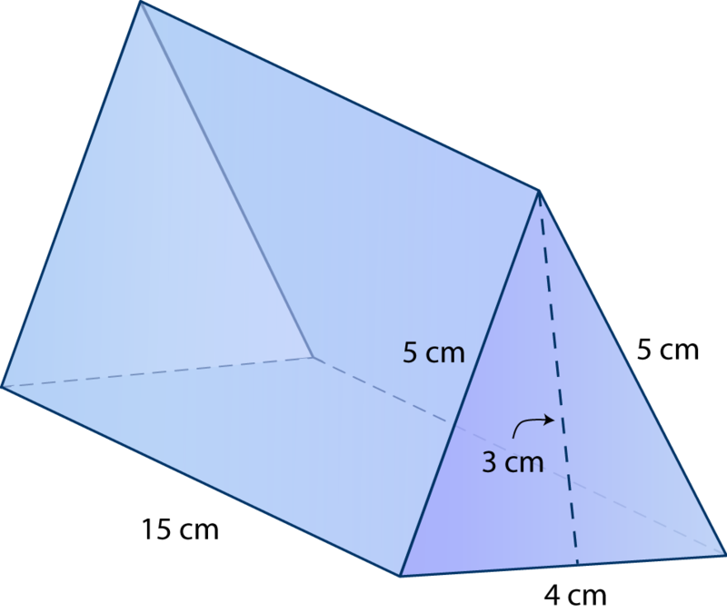 | 2. A baseball has a diameter of 7.4 centimeters. What is the area of the baseball? (Use 3.14 for 𝝅.) (Round to the nearest tenth.)
3. The circumference of a circle is 188 meters. What is the approximate radius of the circle? (Round to the nearest tenth.) | 4. Lillian will draw a scale model of the garden she wants to plant. Her scale is 1 cm = 2.5 ft. What will be the actual dimensions of Lillian’s garden?  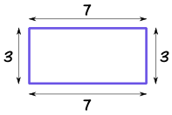  cm  cm

